

**E-MED**

Group No - 3

Team Members:

1. Syed Noor E Newaz (011 181 305)
2. Rakibul Islam (011 181 002)
3. Afroza Sultana (011 181 085)
4. Md Shafiqul Islam (011 181 170)
5. Mohammad Mehedi Hassan Rafi (011 182 096)

**Introduction**

E-med will be the first start-up company in Bangladesh, which is offering you different kinds of medical services on just one platform. Shopping for medicines and other medical products online is a good deal because it saves time, money, and lots of problems. You can earn money via E-med, reuse it through buying medicines and other medical equipment. Not only for the user, but we are also offering different kinds of services for the medical companies and Doctors also. We are focused on getting you the healthcare support & help you need so that you can enjoy your best health. Our main target audience is general people, medical companies, and doctors. You can use this platform for various purposes which makes E-med completely unique.

**Motivation**

There are many pharmaceutical companies that hire people to take snap of the prescription to get knowledge about which prescriptions are prescribed by the doctor. As a result, when we leave the doctor chamber, we often face this kind of horrible situation where so many people try to snatch the prescription and take snap of it. This is a harassment situation for a patient actually. So, we decided to create a site where people can upload their prescriptions, when they upload that they will get some money from it. Which will encourage them to upload more prescriptions. As you know it’s all about money.

But here is a twist, this money is a virtual currency. They can’t cash out the money from the site. But they can use it to purchase any product from our site.

**Overview**

E-med is offering several different kinds of medical facilities for the users in just one platform. We have some unique and trending features like online earning money, virtual currency, buying prescriptions, online doctor consultations, upload prescriptions, reuse the currency to buy medicine free etc. Which makes E-med stronger than any other competitor in the market. Also, in the sense of business, we can do more profit through our services. At a time, we are providing you different kinds of services and also, we are making business.

Users can upload prescriptions, then the prescription will be verified by the admin and after getting approved, the user will get 5 TK for each prescription. Suppose, user uploads 10 prescriptions and all the prescriptions got approved, the user will get 10*5 = 50 TK in his/her account.

Users can’t cash out the money but they can reuse it. There is an option to shop medicine in E-med. User can use their money to buy any medicine. That means they are getting the medicine for completely free.

We will collect all the prescriptions and resell the prescriptions to the pharmaceutical companies. As we have bought them from 5 Tk each, we are going to sell this on 7 TK each. If we sell 10 prescriptions, 20 TK will be our profit.

We can also make a profit from our e-commerce shop, as we are selling medicine and medical equipment.

Another feature is doctor consultations. Users can consult with doctors through our platform. In that case, the doctor has to pay a little amount to us. Also, they can feature themselves by paying a subscription fee.

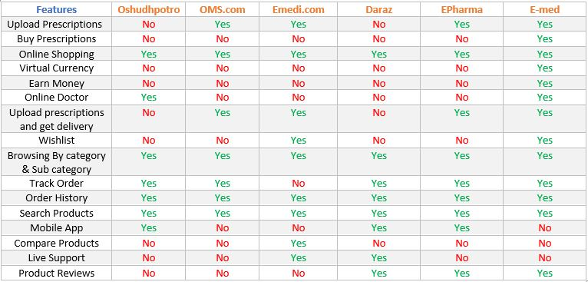**Benchmark Analysis**

**Project Main Features**

* Upload Prescriptions as a user and get virtual money.
* Shop your medicine from the same platform using virtual money or any other payment methods.
* Earn money from the site and reuse it.
* Medicine companies can buy a bunch of prescriptions from the site.
* Prescription plagiarism check.
* At the same time users, companies, and we also get benefited.
* Selling medicine and medical equipment by the same platform.
* Upload Prescriptions and get your medicine at your home.
* Companies can filter prescription by date and time.
* Online Doctor consultation.
* Wishlist and Review system.
* A complete admin panel to manage all the things of the site.
* All the records will be stored in the admin panel.
* Search any products.
* Track order and order history.
* Browsing products by category and Sub category.
* Virtual currency can’t be cashed out.

**Feasibility Analysis**

**Survey report:**

**1.**How often do you buy medicines and other stuff online?

* All the time [ 20% ]
* Occasionally [ 31.4% ]
* Rarely [ 28.6% ]
* Never [ 20% ]

**Descriptions:** It means the demand of online shopping is too high. Only 20% people who never use to shop medicines from online but 80% people prefer online shopping.

**2.**Which online medicine delivery platform do you use?

* Daraz [ 48.6% ]
* Oshudh [ 20% ]
* Emedi [ 25.7% ]
* Oshudhpotro[ 11.4% ]
* Others [ 2.9% ]

**Descriptions:** Our first and main competitor is Daraz or dpharma. Around 50% people use Daraz for online medicine shopping.

**3.** Which types of medicines do you typically buy online?

* Imported Medicines [ 51.4% ]
* Local Medicines [ 28.6% ]
* Rare/uncommon Medicines [ 45.7% ]
* Common Medicines [ 37.1% ]

**Descriptions:** We heard from people about their requirements. Around 52% people shop imported medicines and 46% shop rare medicines.

**4.** What is the biggest concern about buying medicines online?

* Authenticity of Medicines [ 74.3% ]
* Medicines Prices [ 25.7% ]
* Medicines Reviews [ 28.6% ]
* Others [ 2.9% ]

**Descriptions:** Most of the people are concern about the atheneite of medicine. Also, the feedback and reviews playing a vital role here.

**5.** Which features do you think are more useful?

* Earning money via online [ 57.1% ]
* Doctor consultancy via online[ 57.1% ]
* Online shopping [ 48.6% ]
* Other [ 2.9% ]

**Descriptions:** We found our feasible major features, 57% rated earning money online, other 57% rated doctor consultancy. These are the major features of E-med

**6.** "Upload your prescription and earn money from it" - Do you think it can be a great idea?

* Definitely [ 49% ]
* Probably [ 25% ]
* Probably Not [ 14.3% ]
* Never [ 11.4% ]

**Descriptions:** This is the main feature of E-Med. Around 50% people liked it and 25% people are not sure about it.

**7.**Will you use our service in the future?

* Definitely [ 45.6% ]
* Probably [ 48.6% ]
* Probably Not [ 0% ]
* Never [ 2% ]

**Descriptions:** Thinking about the future the outcome is really good. Around 46% people are agreeing to use the platform and 48% are not sure about it.

**8.** Will you recommend E-Med to others?

* Definitely [ 45.7% ]
* Probably [ 42.9% ]
* Probably Not [ 5.7% ]
* Never [ 5.7% ]

**Descriptions:** People are also interested to recommend us to other.

**Decisions from the survey**

We have collected around 50 people’s data and after completing the survey, we have fixed our final features. We realize that most of our features are liked by the user. This survey also helps us to know the strengths and weaknesses of our project.

We also get to know our target users and our main competitor. This survey help gauge the representativeness of individual views and experiences. We have got people opinions and behaviors that helps us to make important decisions.

We have added some extra new features to E-med after the survey and remove some features from it too.

**The Final Features**

* Upload Prescriptions and earn money
* Sale prescriptions to the medial pharmaceutical company
* Online medicine and medical equipment’s shopping
* Online doctor consultancy
* Earn money from the site and reuse it.
* Search medicines
* Product reviews and feedbacks
* Browsing products by category and Sub category.
* Wishlist system

DIAGRAM

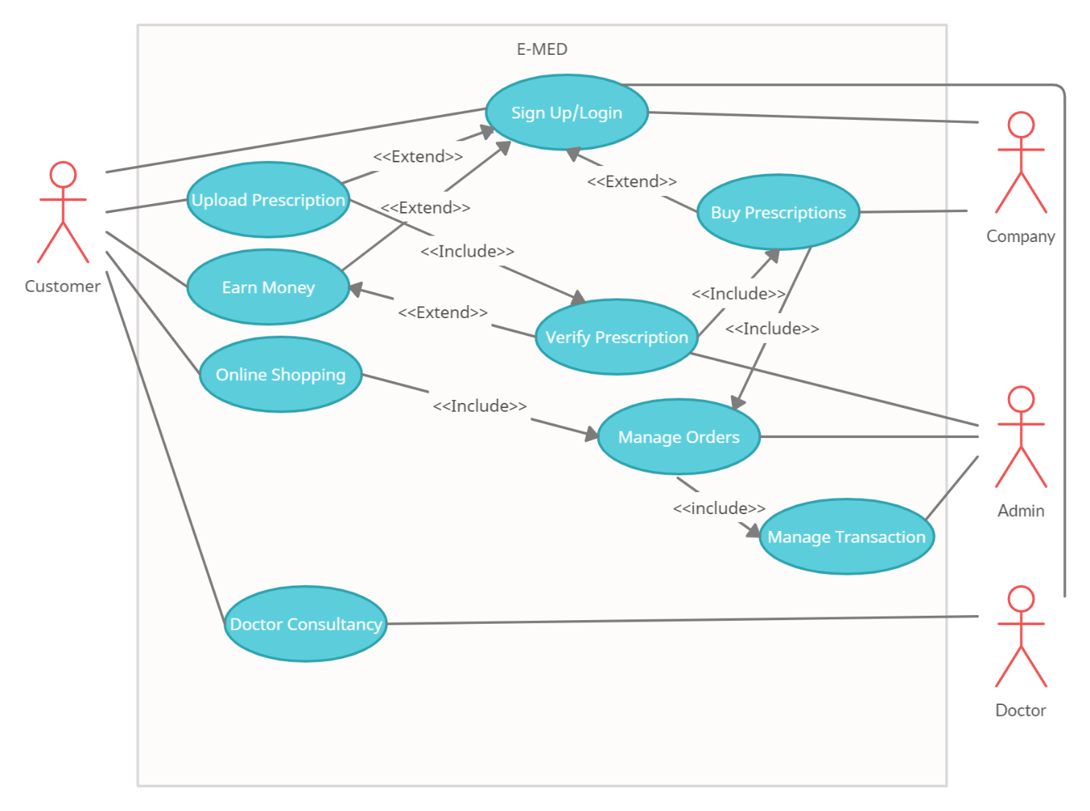USE CASE

Use Case Descriptive

* **Use Case 1:**

Upload Prescriptions

* **Primary Actor:**

Customer or user

* **Stakeholders And Interests:** 
  + **User or Customer:** Wants to upload prescriptions smoothly without any error.
  + **Admin:** Verify prescriptions.
* **Pre-Condition:**
  + Users must have to register on the site.
  + Should be an authorized user.
* **Post Conditions:** 
  + Prescriptions will remain in the database if user logs out.
  + Users can see the status of verification of their prescriptions.
  + Changes are made in the database.
* **Main Success Scenario:**
  + User logs into the system using the username and password.
  + Users uploads the prescription to the system.
  + Admin verifies prescriptions.
  + System records the entry of user.
  + After getting approved, users will get money.
* **Alternate Scenario:**
  + At any time, system can be down.

**Solutions:** System is recovered to prior state.

* + User may not find the option to upload prescriptions.

**Solutions:** Highlight the option more than twice in the system.

* + System may have bugs or system errors.

**Solutions:** Contact the admin and let us know.

* **Issues:**
  + If username and password is not correct, error message will be shown.
  + If the user doesn’t provide proper information, an error will be shown.

Data Flow Diagram (DFD)

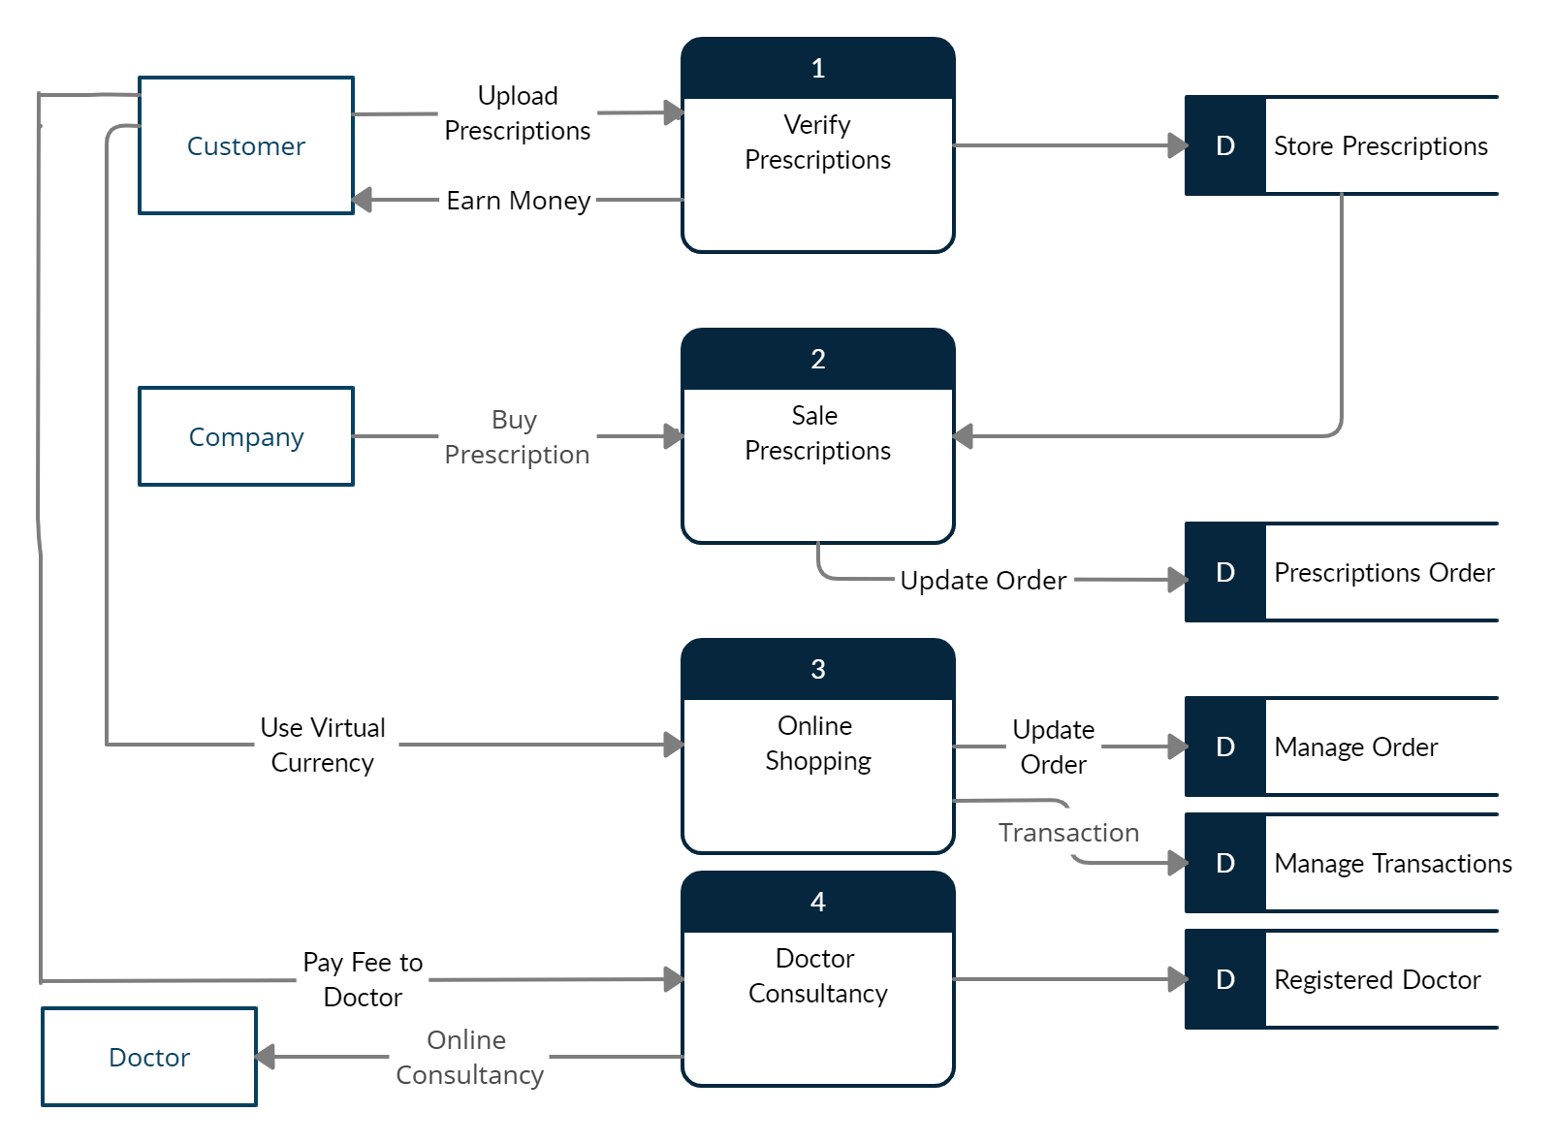

Class Diagram

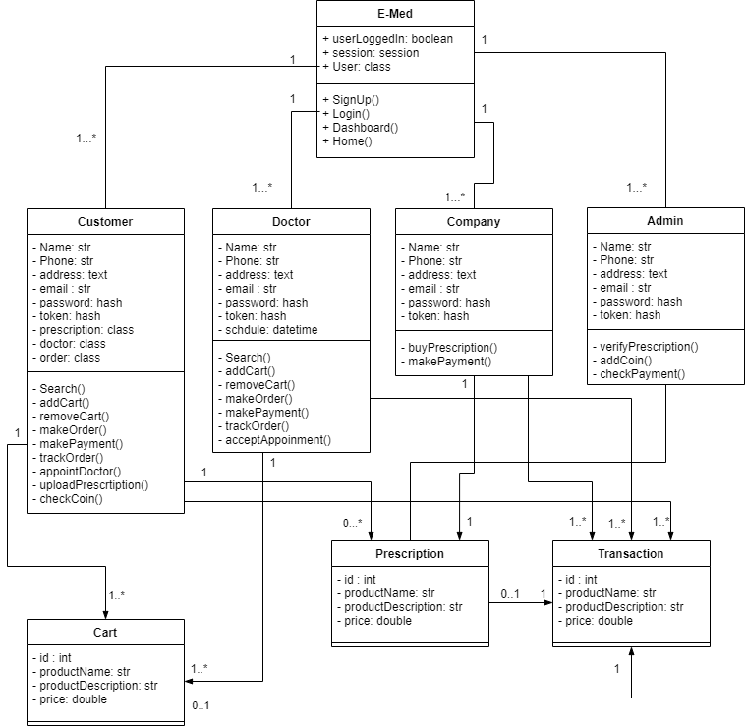

SWOT Analysis

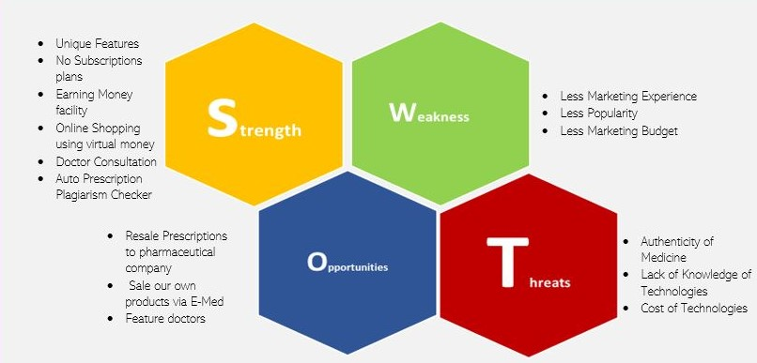

**Strength:**

We have some unique and trending features like earning money, virtual currency, buying prescriptions, online doctor consultations etc. Which makes E-med stronger than any other competitor in the market. Also, in the sense of business, we can do more profit through our services. At a time, we are providing you different kinds of services and also, we are making business.

**Weakness:**

In SWOT analysis, weakness is an internal characteristic. Our main weakness is we don’t have any marketing experience and as we are providing some unique features, it is important for us to do marketing. Also, we need a huge budget to do marketing.

**Opportunities:**

We have some great opportunities to make success on the project. As we are providing different kinds of features, we believe we can make a profit out of it. We can resell prescriptions, sell our own medicines using e-commerce facilities. Our doctor consultations feature will also help us to grow in the market.

**Threats:**

As threats is an external characteristic, we must need to think about the threats. Our main threats are, make sure the quality of the medicine we are providing. Then comes the cost of technologies and lack of knowledge in technology. Most of the people in our country don’t know how to use technologies as a result, it will be tough for us to get success in a short time.

Screenshots of the Project

**Home Page**

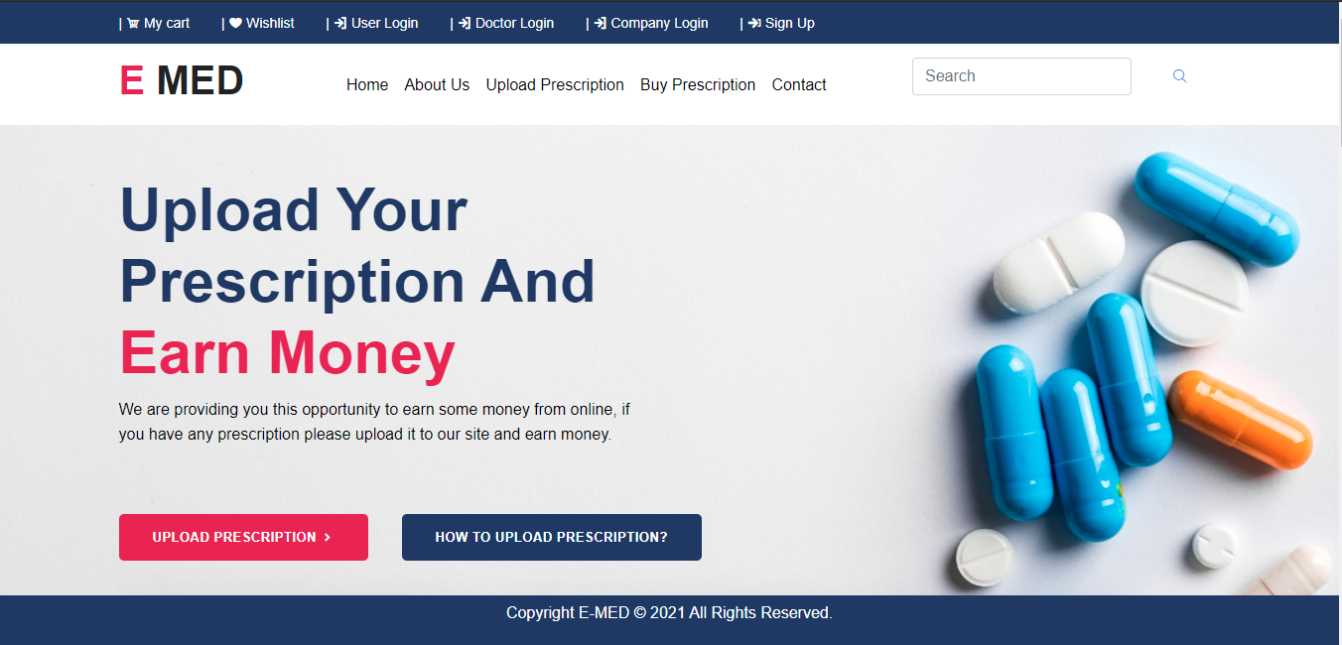

**Product**

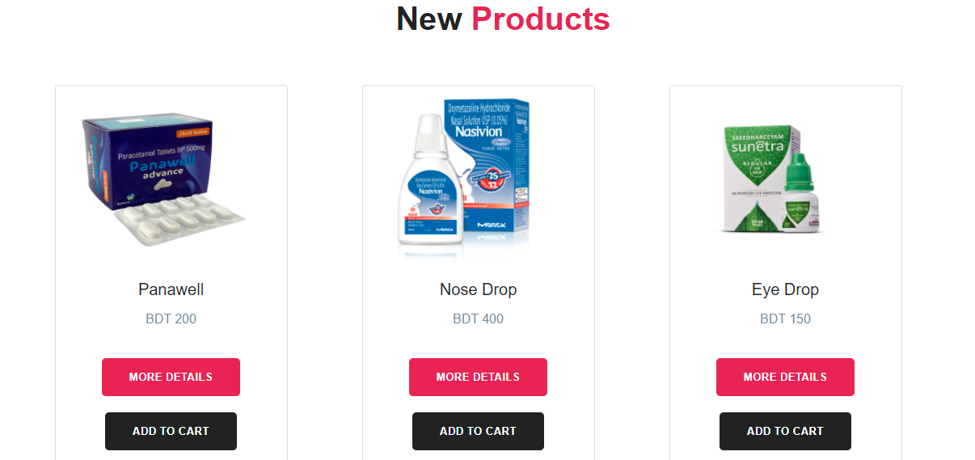

**Single Product Page**

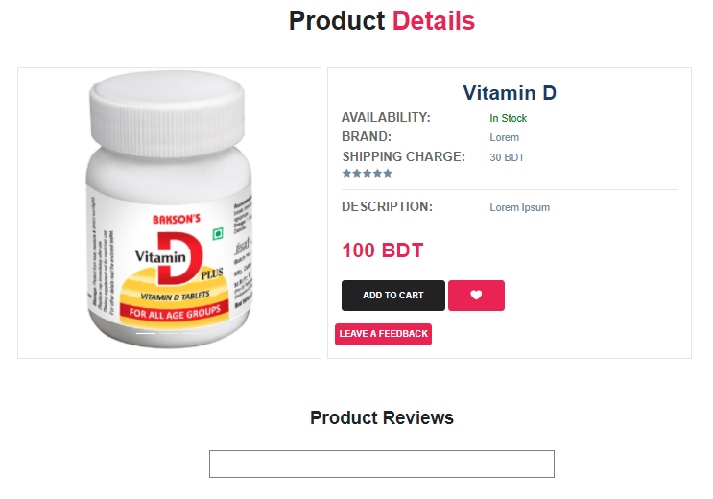

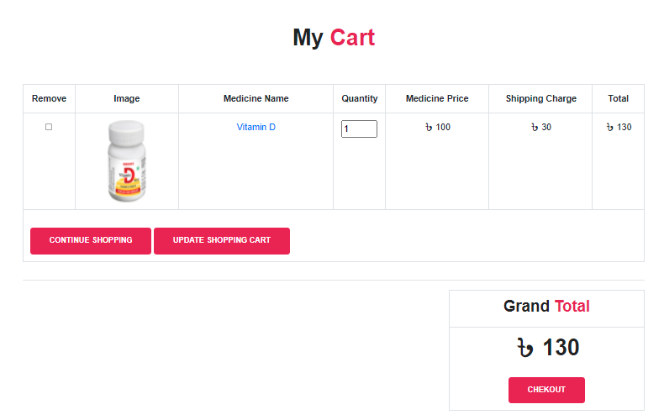**Cart View**

**Upload Prescription**

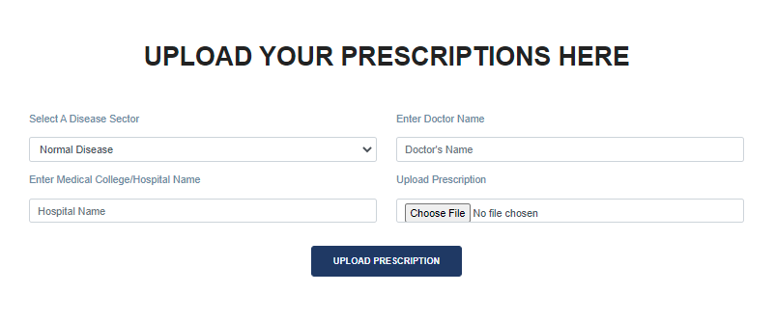

**Doctor Profile**

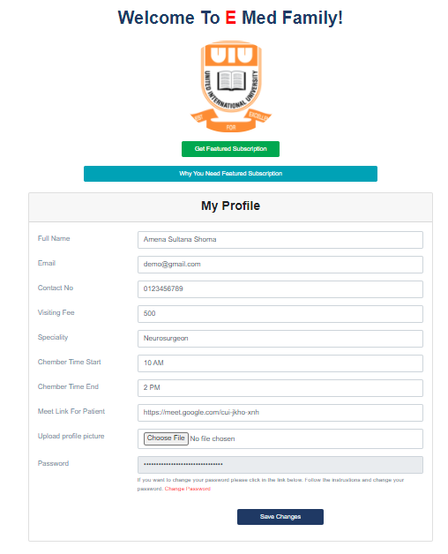

**Doctor Page ( User End)**

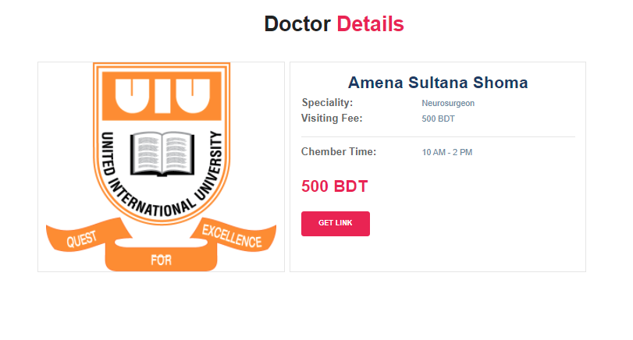

**Doctor Homepage**

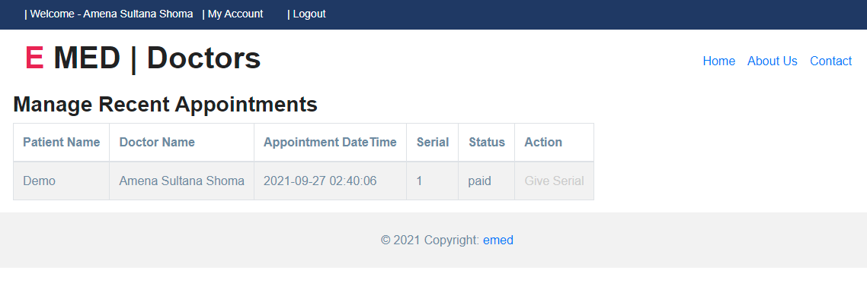

**Doctor Appointment and Meet**

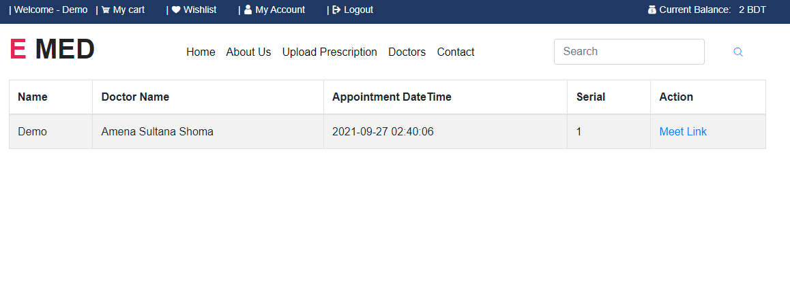

**Buy Prescription**

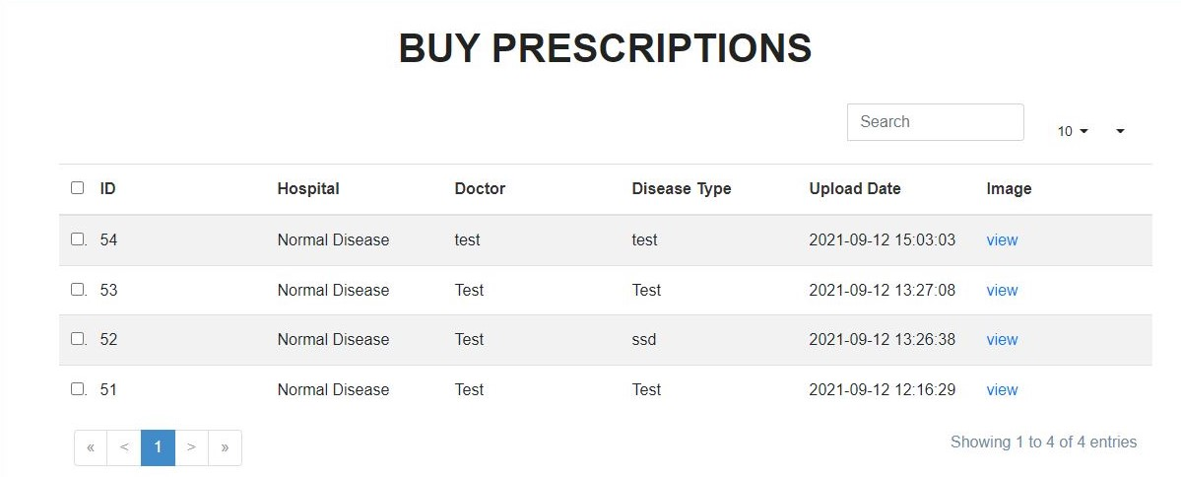

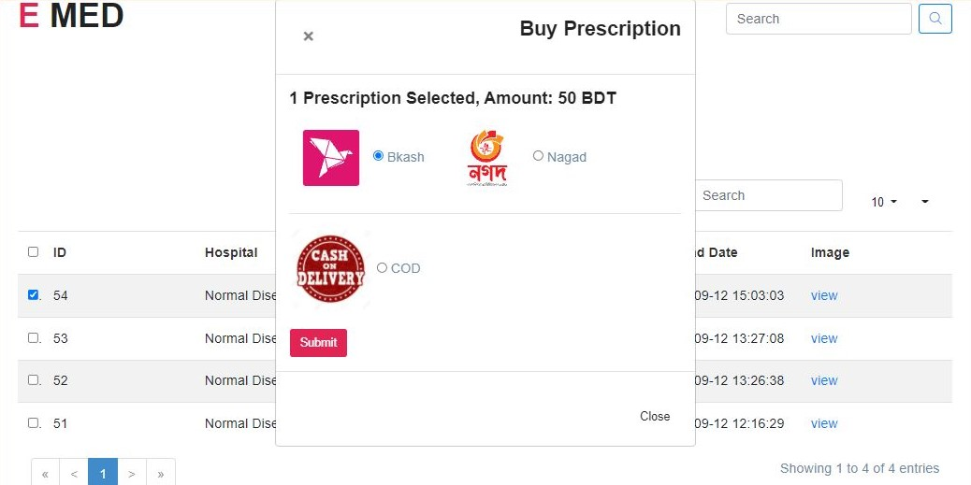

**Future Work**

In this session we can really relate that the project will play a vital role in the system. Moreover, people from companies won't able to gather places to take photos of the prescriptions. They could get those from us easily with very small number of charges.

Therefore, Patients have their facilities for doctor consultancies. Doctors also have a platform for to communicate their patients easily as it is pandemic some patients cannot even visit doctors practically. Upload prescription from patient side will reward them virtual currency with which they will able to buy prescriptions.

However, our projects income and expenditure will especially come from selling medicine and prescriptions. The significance of our E-med will make things pretty easier for the patient, doctors, sellers and all.

In future it will make a drastic change in this platform as we are providing maximum features in the same platform.

References

* [**https://theomandel.com/resources/golden-rules-of-user-interface-design/**](https://theomandel.com/resources/golden-rules-of-user-interface-design/)
* [**https://creately.com/lp/uml-diagram-tool/**](https://creately.com/lp/uml-diagram-tool/)
* [**https://stackoverflow.com/**](https://stackoverflow.com/)
* [**https://www.mindtools.com/pages/article/newTMC_05.htm**](https://www.mindtools.com/pages/article/newTMC_05.htm)
* [**https://laptrinhx.com/the-6-design-principles-of-don-norman-470095013**](https://laptrinhx.com/the-6-design-principles-of-don-norman-470095013)